How can Big Mountain Resort maintain the business's profit margin at 9.2% or higher by offsetting the newly incurred operational costs of $1.54M with an adjustment of ticket prices, operational costs, and revenue generation this year?

Currently Big Mountain Resort is not included in the data provided. All calculations, predictions, and figures are related to averages provided in the data and does not directly relate to Big Mountain Resort.

Once cleaning and exploring the data set I realized that the most important row was missing. My first step was to widen my scope to the entire data set. If we can find out how every other ski resort is doing then we can at least create some criteria that a ski resort needs to maintain a profit margin of 9.2% with the added expense of a $1.54 million ski lift.
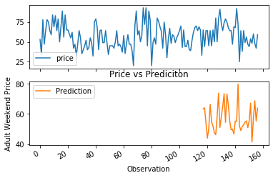
We can tell from the predictive model that prices overall are predicted to drop from $57.74 to $57.22 for chair lift ticket prices. From this model we can assume that the market will not allow too high of an increase in prices without loss of business to competition. From this inference we know that we will need to change more than ticket prices to maintain a profit margin of 9.2%.

If a Big Mountain Resort chair lift ticket price is the average, then 26,916 tickets need to be sold to break even and 29,392 tickets need to be sold to reach our goal. There is also the possibility of lowering this amount if Big Mountain Resort acquires certain criteria and is able to increase ticket prices.
Since Big Mountain Resort’s seasonal population is roughly 350,000 people, we can say that there is a good chance of Big Mountain Resort being large and will be able to meet this criteria.
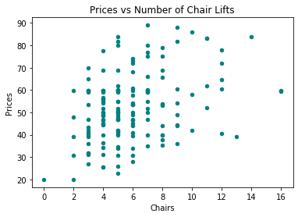
There is an argument supporting the amount of chair lifts a resort has increases the price overall per ticket. This correlation is weak and can be seen in figure 6. If Big Mountain Resort has many chair lifts, and this is more likely because of the new investment, the chair lift ticket prices can be raised. This is likely going to be a small amount and will increase profit only marginally.

There is little to no correlation between summit elevation and chair lift price. The size of mountain that Big Mountain Resort is perched on will not make it more or less desirable to potential skiers and snowboarders. Nor is there a correlation between prices and days open. Although staying open longer means more opportunities for people to purchase chair lift tickets. However this factor is not controllable by Big Mountain Resort.
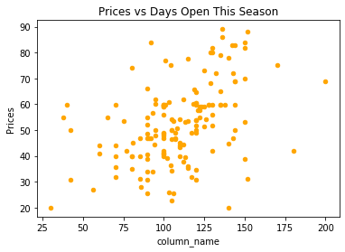

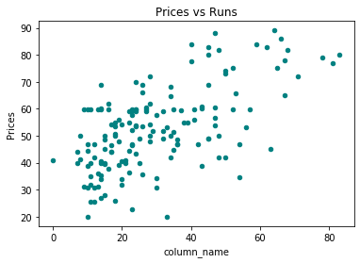
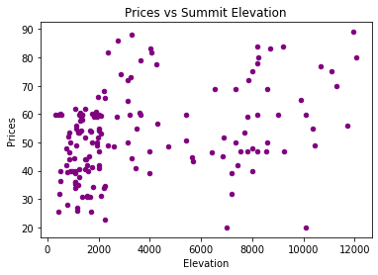

There is a weak correlation between higher ski resort prices and the amount of runs. This correlation is illustrated in figure 8. This suggests a ski resort with a higher number of runs can charge more for ski lift tickets. One solution for Big Mountain resort would be to segment ski runs with artificial barriers producing the illusion of more runs. This would allow the market to charge a higher price.

Ultimately if Big Mountain Resort is able to segment runs and lower operational costs this year could maintain the desired profit margin. I suspect with the new equipment lowering operational costs would be difficult if at all feasible. However if the resort is large enough to maintain many runs and corresponding ski lifts, ticket prices will be able to be increased enough to maintain a 9.2% profit margin despite the prediction of lower ski lift ticket prices.
I was able to come up with the Chairs_x_Runs score which is the amount of chairs multiplied by the amount of runs. This provides an arcing plot that allows us to determine the relationship between prices and the Chairs_x_Runs score. 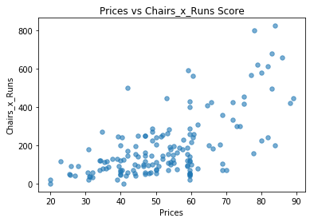
Depending on where Big Mountain Resort’s Chair_x_Runs score falls we can calculate the price we charge for chair lift tickets.

Profit_Margin = (Tickets_Sold*Price)-Operational_Costs

